The most popular Belarusian dishes are considered to be machanka and pancakes, that often welcome guests at the dinner table and complement each other.

Machanka

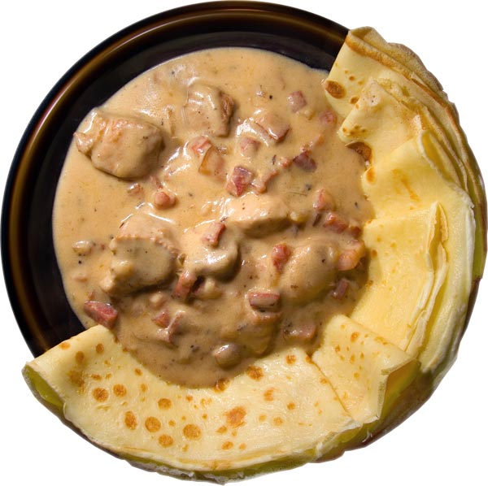
The name of the dish comes from a word “to dip”. Machanka is prepared from roasted pork ribs or lean pork and stew in a pan, or as it was several decades ago in the clay pots. But many housewives try to do all the cooking rules. Machanka is nice with pancakes.

Ingredients
200g lean pork
50g fat
50g raw sausages
100g smoked brisket
1 onion
1 spoon of water or milk
Salt
Black pepper

Preparation

http://www.youtube.com/watch?v=i3UcJ5HtTLk

Draniki

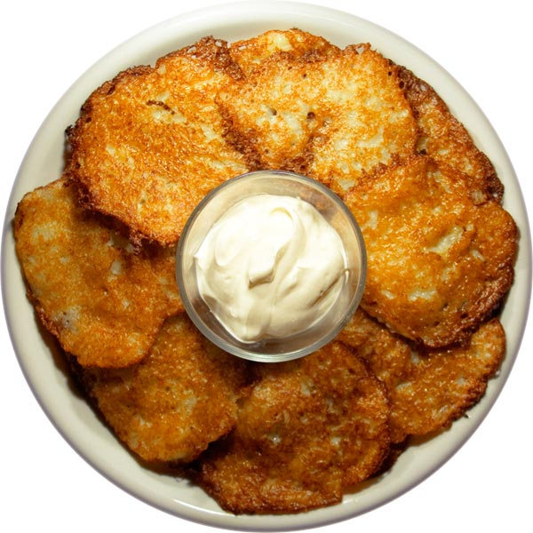
Pancakes is a very famous dish of Belarusian cuisine, which represents the potato. Pancakes are very tasty and simple. Draniki allow many variations: you can cook them with mushrooms and meat, carrot and pumpkin. There are many variants, every woman makes them a little differently.

Ingredients
Potatoes 1 kg
1 onion
Salt
Oil for frying (refined)

Preparation
http://www.youtube.com/watch?v=doIDD1IkjVA&feature=related

